First 30 things to do after installing Ubuntu

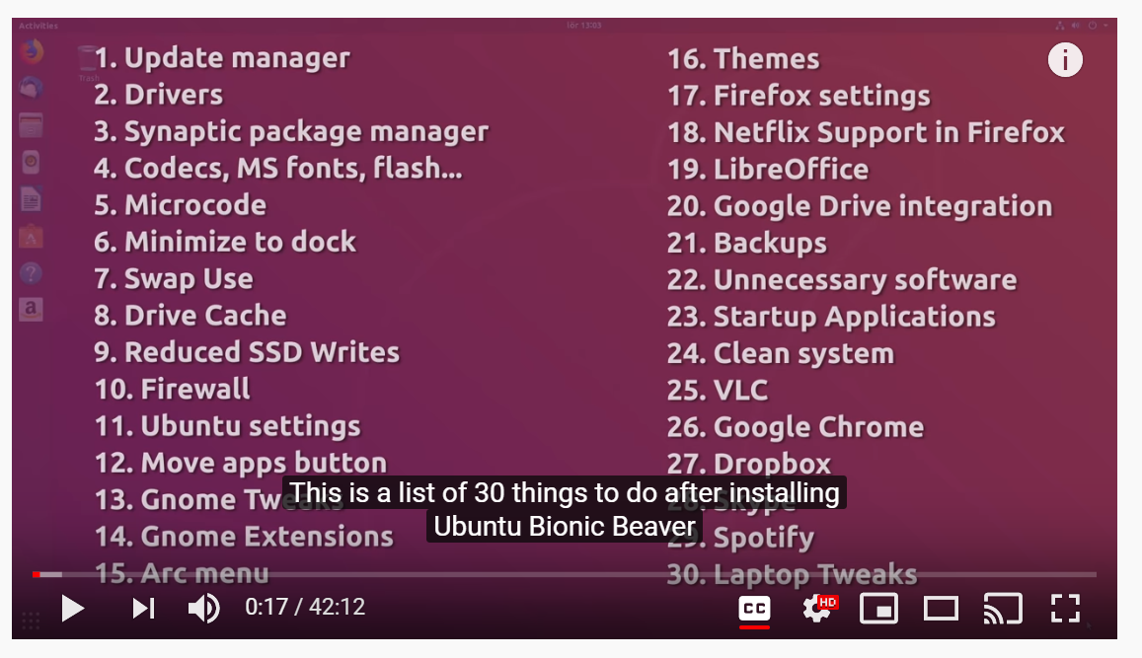

1. I didn’t install flash-player of dvd or audio drivers
2. I didn’t install intel-microcode.
3. I did not enable “disk write caching”.
4. SSD
   1. Trim
   2. Reduce write cycles

